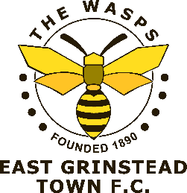
Kit Order Form
(email to eastgrinsteadtownfc@gmail.com or hand in at Club)

Name: _____________________________________________________

Contact Tel No: ______________________________________________

Contact Email: _______________________________________________

Shirts: (NOTE ALL SHIRTS ORDERED WILL EITHER HAVE MCDONDALDS AS SHIRT SPONSOR OR HAVE NO SPONSOR)
Home
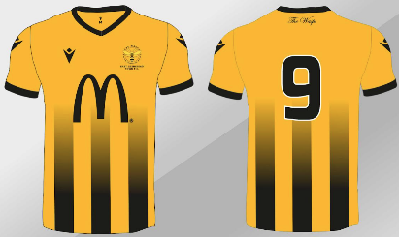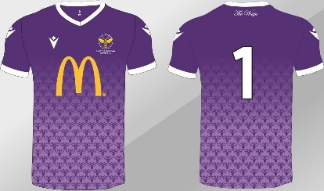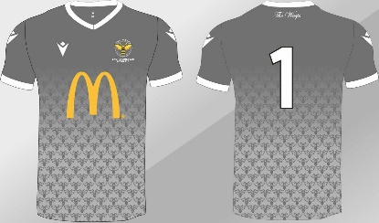
Away
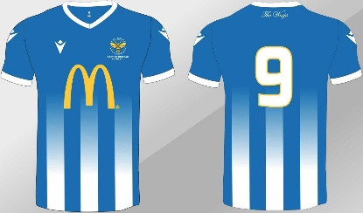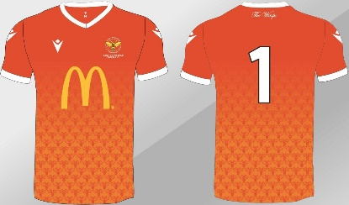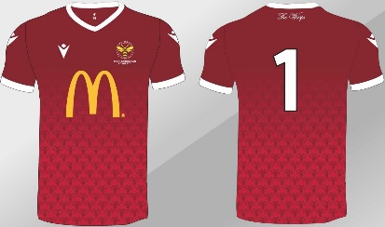

Prices:
Adult Shirts: £36 Junior Shirts: £30 Add a Shirt Number: £2
Payment required upfront in full and non-refundable as shirts are made to order

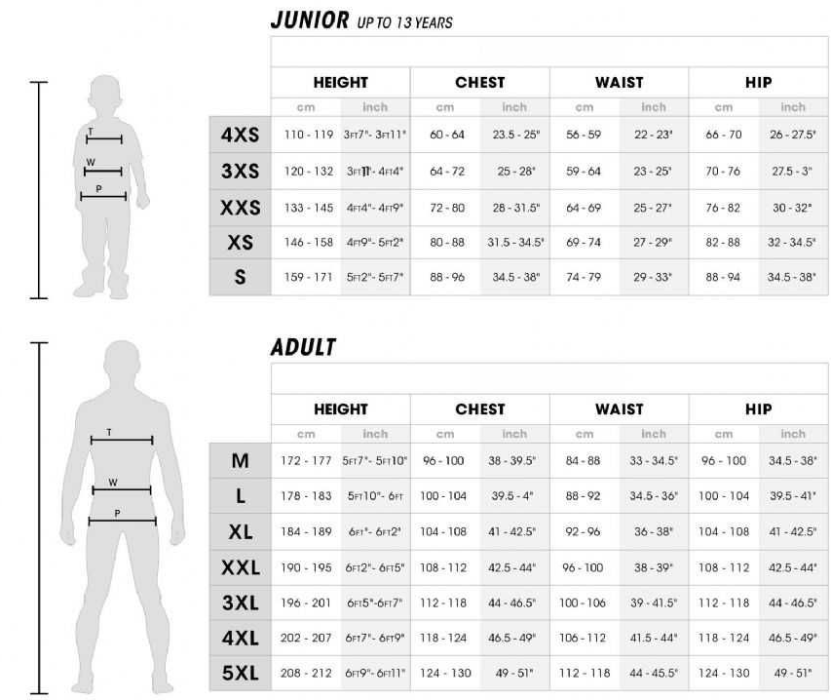
Order: (tick or write number of shirts required in relevant box below)
Macron Size Guide
Size |  | Outfield |  | Goalkeeper
 |  | Home | Away | Home - Purple | Home - Grey | Away - Orange | Away - Red
Junior: | 4XS
 | 3XS
 | XXS
 | XS
 | S
Adult: | M
 | L
 | XL
 | XXL
 | 3XL
 | 4XL
 | 5XL
Shirt Sponsor (McDonalds = default or Blank)
No Shirt Number (Default):
Specify Shirt Number:
Orders will be placed on 2nd December 2023 – Delivery estimate >6 weeks to Club for collection.
Home Delivery will be charged in addition at cost.

